

Grupo: 2.B

Profesor: Joel Vázquez

Nombre: Daniela Beatriz Martínez Montes

Matricula: 1603150184

SISTEMAS DIGITALES

|  |  |  |  |
| --- | --- | --- | --- |
|  |  |  |  |
|  |  |  |  |

|  |  |  |  |  |  |  |  |  |  |  |  |  |
| --- | --- | --- | --- | --- | --- | --- | --- | --- | --- | --- | --- | --- |
|  |  |  |  |  | **TABLA DE VERDAD** | | | |  |  |  |  |
|  |  |  |  |  |  |  |  |  |  |  |  |  |
|  | **X** | **Y** | **Z** | **W** | **a** | **b** | **c** | **d** | **e** | **f** | **g** |  |
|  | 0 | 0 | 0 | 0 | ***1*** | ***1*** | ***1*** | ***1*** | ***1*** | ***1*** | ***0*** |  |
|  | 0 | 0 | 0 | 1 | ***0*** | ***1*** | ***1*** | ***0*** | ***0*** | ***0*** | ***0*** |  |
|  | 0 | 0 | 1 | 0 | ***1*** | ***1*** | ***0*** | ***1*** | ***1*** | ***0*** | ***1*** |  |
|  | 0 | 0 | 1 | 1 | ***1*** | ***1*** | ***1*** | ***1*** | ***0*** | ***0*** | ***1*** |  |
|  | 0 | 1 | 0 | 0 | ***0*** | ***1*** | ***1*** | ***0*** | ***0*** | ***1*** | ***1*** |  |
|  | 0 | 1 | 0 | 1 | ***1*** | ***0*** | ***1*** | ***1*** | ***0*** | ***1*** | ***1*** |  |
|  | 0 | 1 | 1 | 0 | ***1*** | ***0*** | ***1*** | ***1*** | ***1*** | ***1*** | ***1*** |  |
|  | 0 | 1 | 1 | 1 | ***1*** | ***1*** | ***1*** | ***0*** | ***0*** | ***0*** | ***0*** |  |
|  | 1 | 0 | 0 | 0 | ***1*** | ***1*** | ***1*** | ***1*** | ***1*** | ***1*** | ***1*** |  |
|  | 1 | 0 | 0 | 1 | ***1*** | ***1*** | ***1*** | ***0*** | ***0*** | ***1*** | ***1*** |  |
|  | 1 | 0 | 1 | 0 | ***1*** | ***1*** | ***1*** | ***0*** | ***1*** | ***1*** | ***1*** |  |
|  | 1 | 0 | 1 | 1 | ***0*** | ***0*** | ***1*** | ***1*** | ***1*** | ***1*** | ***1*** |  |
|  | 1 | 1 | 0 | 0 | ***1*** | ***0*** | ***0*** | ***1*** | ***1*** | ***1*** | ***0*** |  |
|  | 1 | 1 | 0 | 1 | ***0*** | ***1*** | ***1*** | ***1*** | ***1*** | ***0*** | ***1*** |  |
|  | 1 | 1 | 1 | 0 | ***1*** | ***0*** | ***0*** | ***1*** | ***1*** | ***1*** | ***1*** |  |
|  | 1 | 1 | 1 | 1 | ***1*** | ***0*** | ***0*** | ***0*** | ***1*** | ***1*** | ***1*** |  |
|  |  |  |  |  |  |  |  |  |  |  |  |  |

**MAPAS DE KARNAUGH**













**DISPLAY**

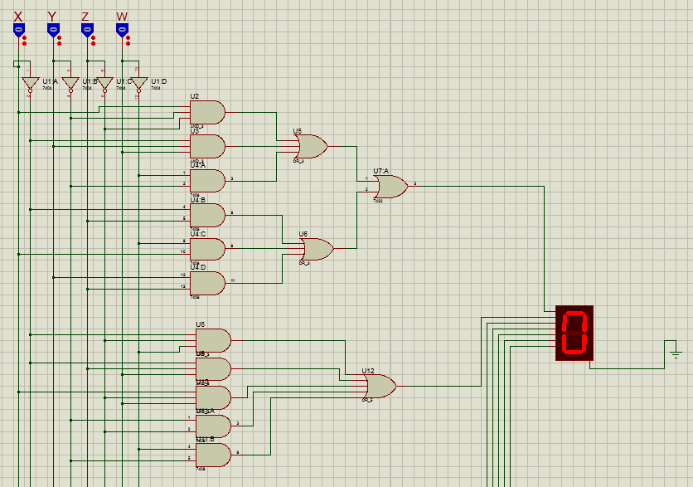**Imágenes del circuito en proteus**

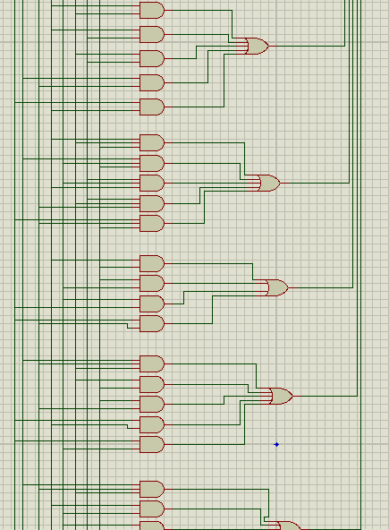

**Número 0.**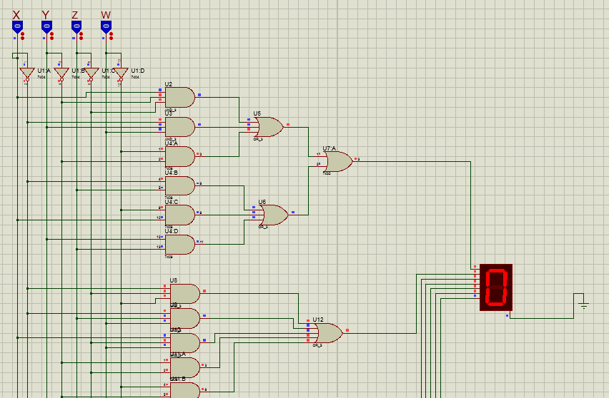

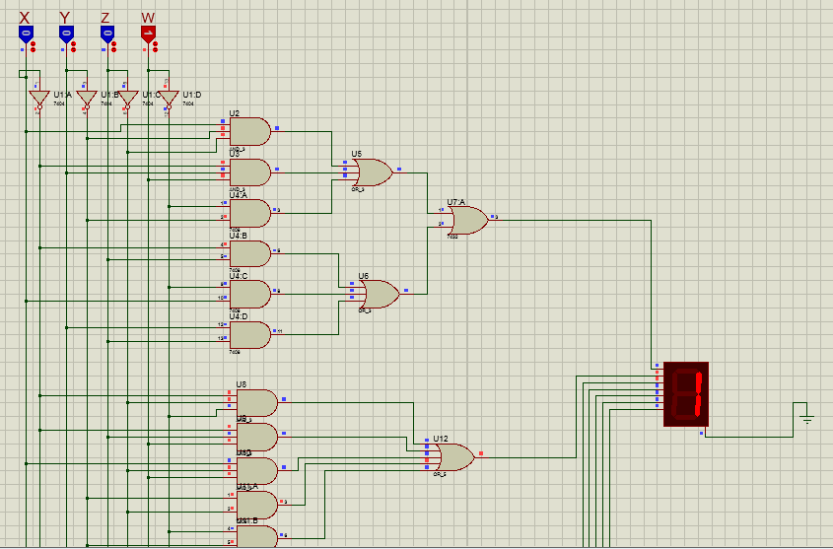**Número 1:**

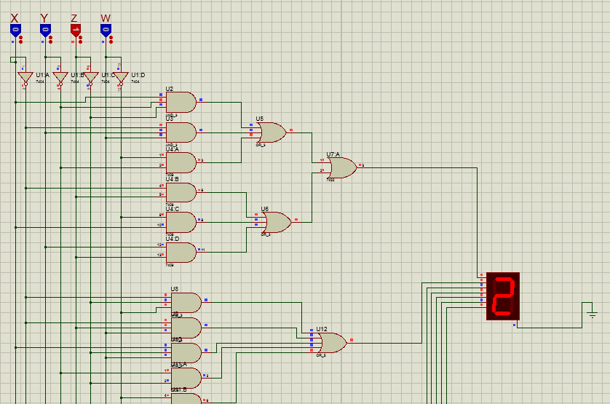**Número 2:**

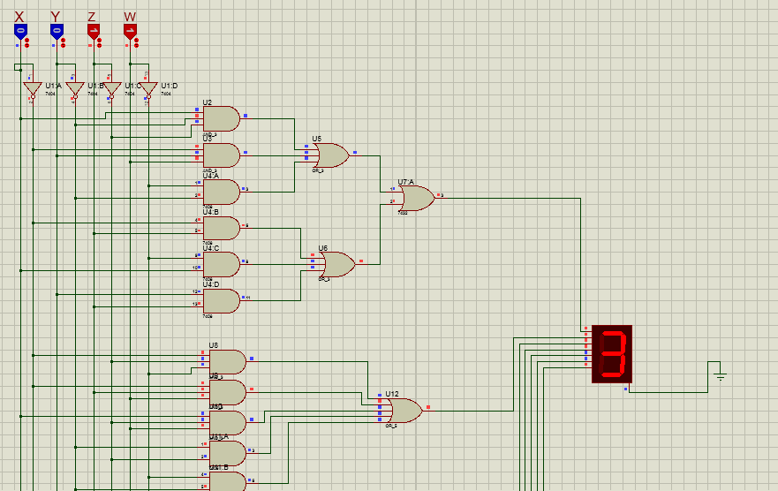**Número 3:**

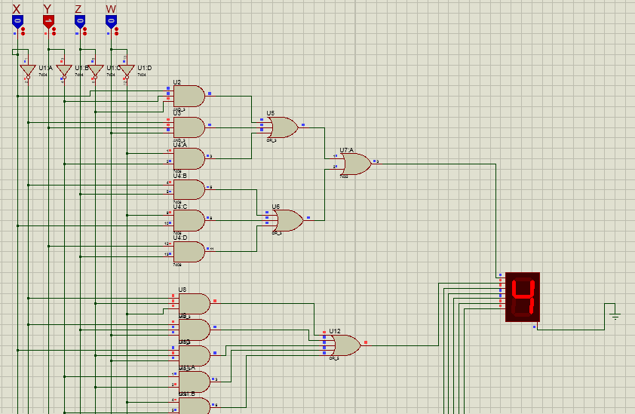**Número 4:**

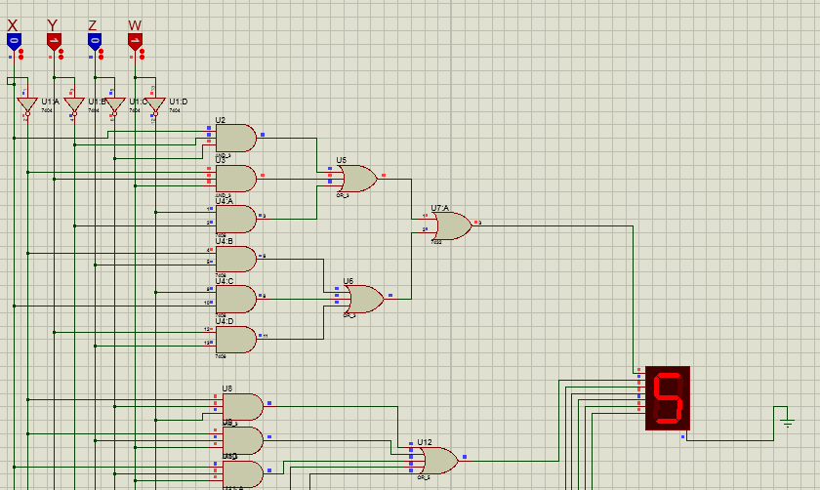**Número 5:**

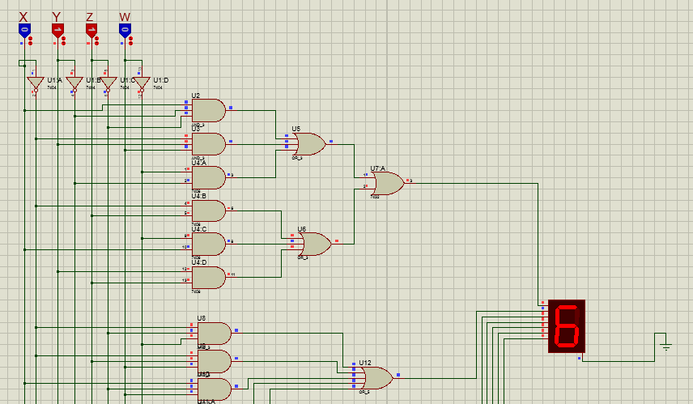**Número 6:**

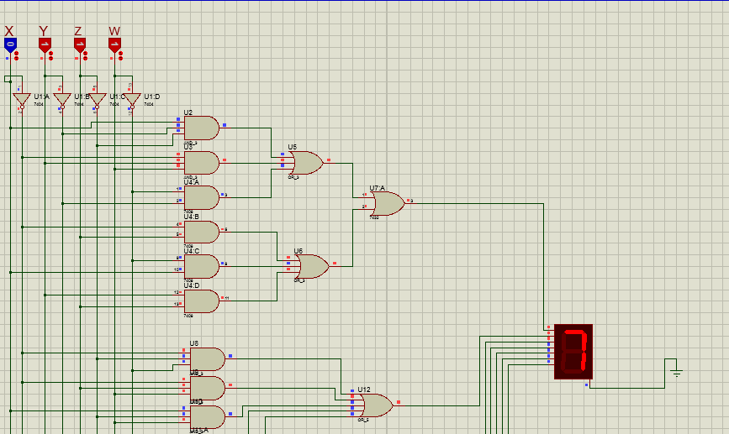**Número 7:**

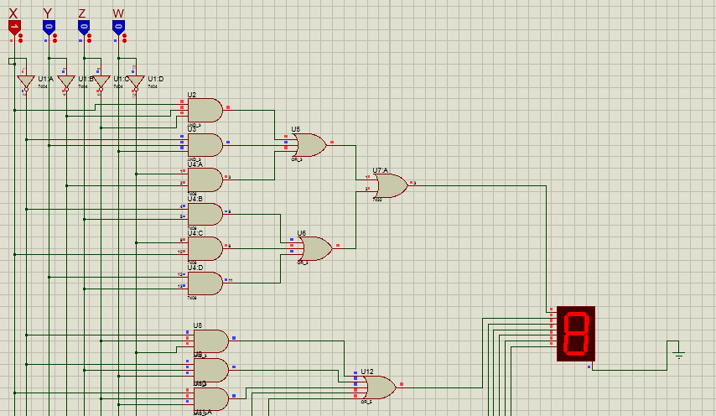**Número 8:**

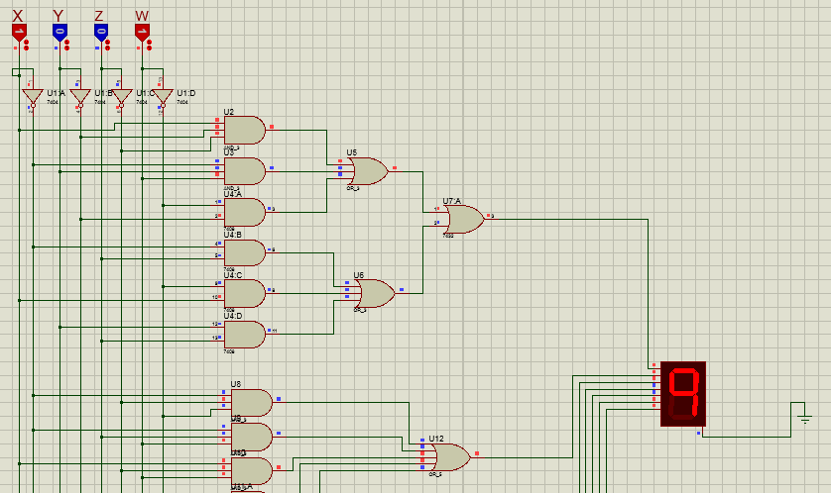**Número 9:**

**Número 10:**

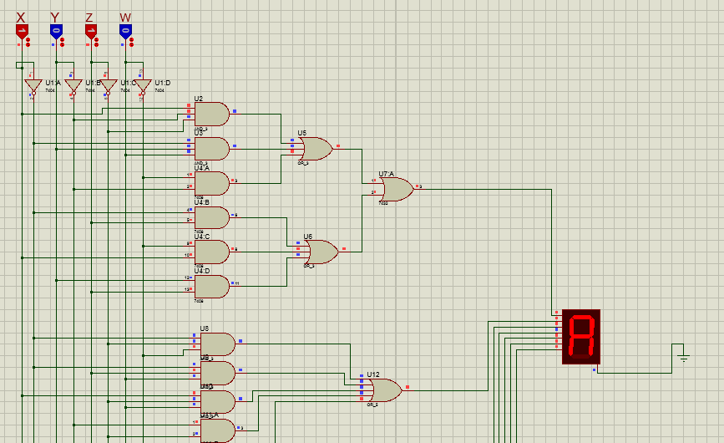

**Número 11:**

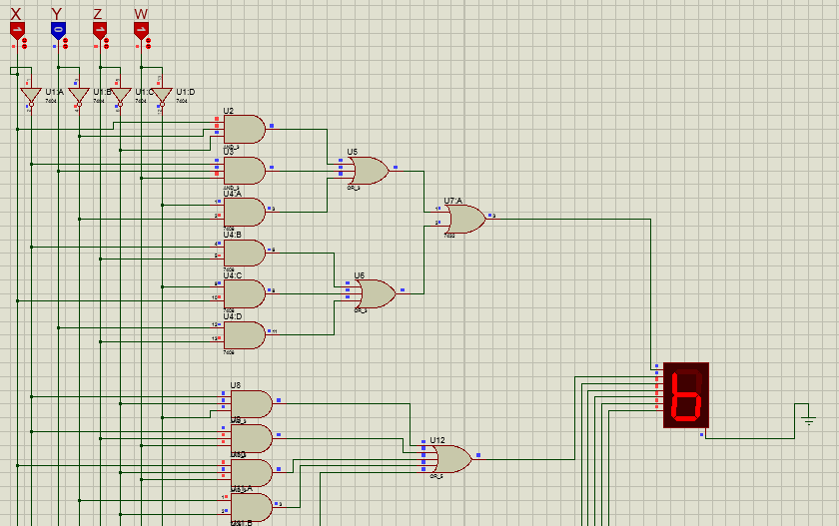

**Número 12:**

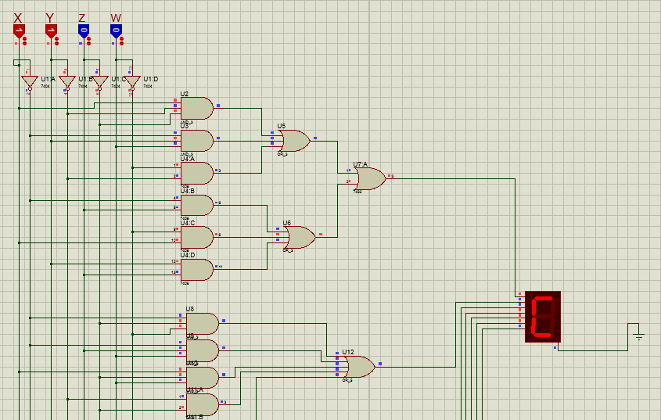

**Número 13:**

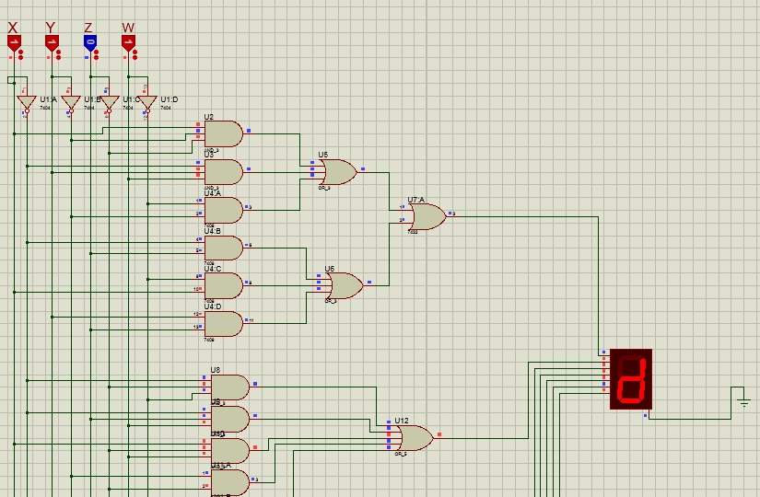

**Número 14:**

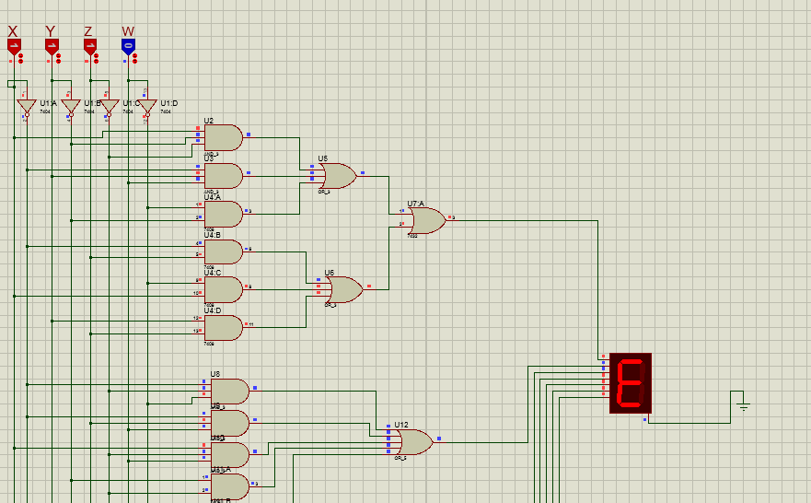

**Número 15:**

